PYTHON PROGRAMS – AI PROBLEM SOLVING LAB
10 programs with sample outputs

1. 8-Puzzle Problem (A* Search)
Aim: Solve the 8-puzzle using A* search.

Program
from heapq import heappush, heappop

goal = (1, 2, 3, 4, 5, 6, 7, 8, 0)

def heuristic(state):
return sum(1 for i, x in enumerate(state)
if x != 0 and x != goal[i])

def solve(start):
pq = [(heuristic(start), 0, start, [])]
visited = set()

while pq:
_, cost, state, path = heappop(pq)

if state == goal:
return path + [state]

if state in visited:
continue
visited.add(state)

z = state.index(0)
r, c = divmod(z, 3)

for dr, dc in [(1, 0), (-1, 0), (0, 1), (0, -1)]:
nr, nc = r + dr, c + dc

if 0 <= nr < 3 and 0 <= nc < 3:
nz = nr * 3 + nc
new = list(state)
new[z], new[nz] = new[nz], new[z]
new = tuple(new)

if new not in visited:
heappush(pq, (cost + 1 + heuristic(new),
cost + 1, new, path + [state]))

start = (1, 2, 3, 4, 5, 6, 0, 7, 8)
result = solve(start)

for state in result:
print(state[:3])
print(state[3:6])
print(state[6:])
print()

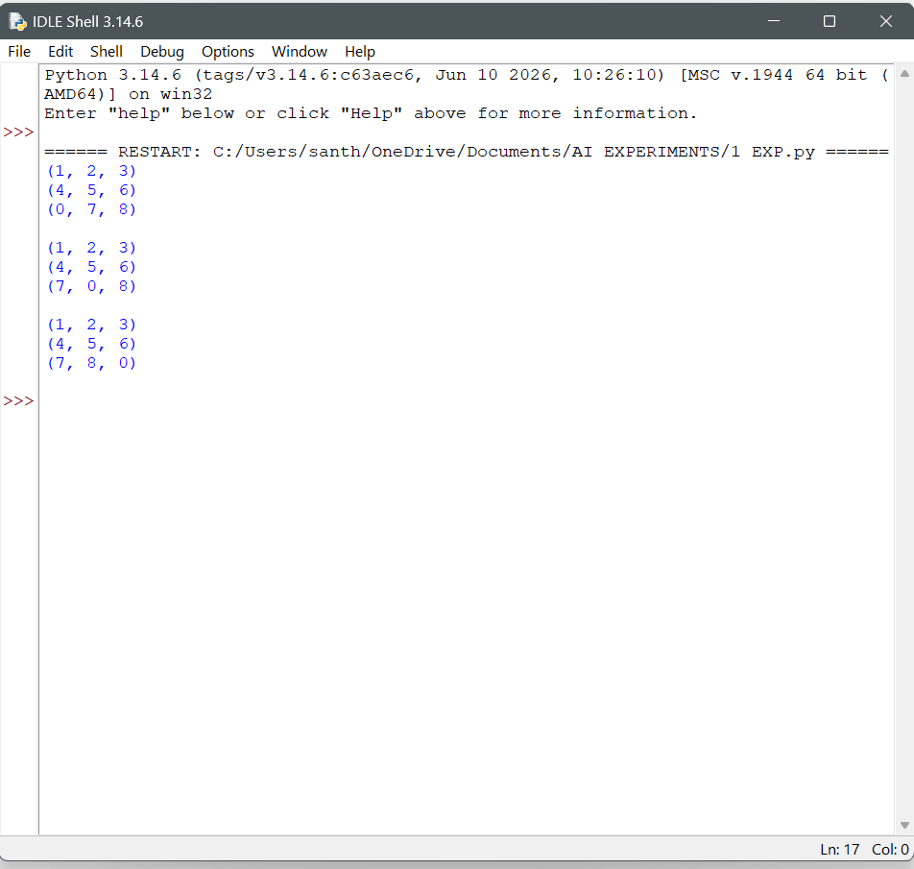

2. 8-Queen Problem
Aim: Place eight queens so that no two queens attack each other.

Program
N = 8
board = [-1] * N

def safe(row, col):
for r in range(row):
if board[r] == col:
return False
if abs(board[r] - col) == abs(r - row):
return False
return True

def solve(row):
if row == N:
return True

for col in range(N):
if safe(row, col):
board[row] = col
if solve(row + 1):
return True
board[row] = -1
return False

if solve(0):
for r in range(N):
print(" ".join("Q" if board[r] == c else "-"
for c in range(N)))

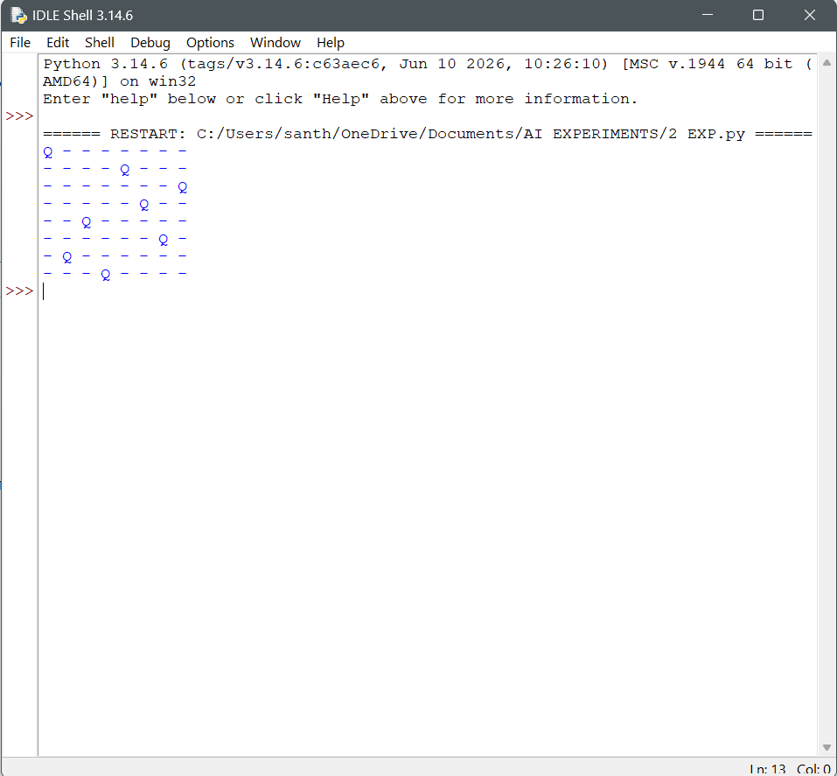

3. Water Jug Problem
Aim: Measure 2 litres using 4-litre and 3-litre jugs.

Program
from collections import deque

def water_jug():
start = (0, 0)
queue = deque([(start, [])])
visited = {start}

while queue:
(a, b), path = queue.popleft()

if a == 2 or b == 2:
for state in path + [(a, b)]:
print(state)
return

pour = min(a, 3 - b)
pour2 = min(b, 4 - a)
moves = [
(4, b), (a, 3), (0, b), (a, 0),
(a - pour, b + pour),
(a + pour2, b - pour2)
]

for state in moves:
if state not in visited:
visited.add(state)
queue.append((state, path + [(a, b)]))

water_jug()

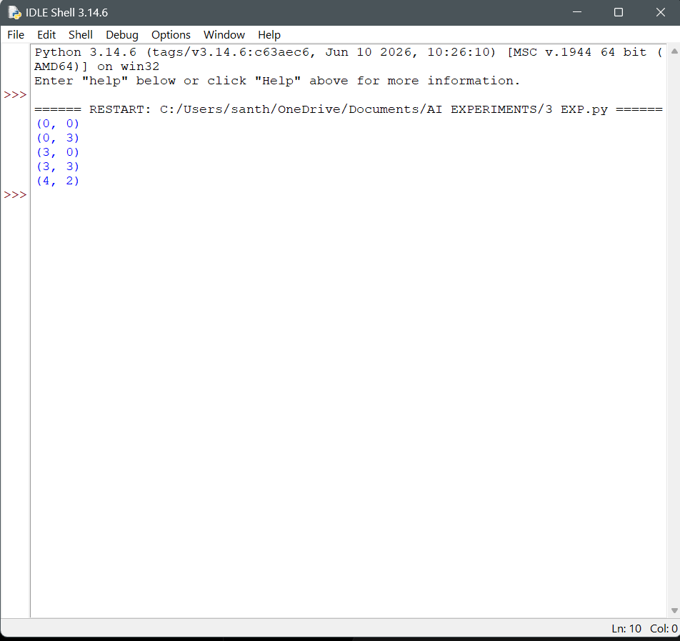

4. Crypt-Arithmetic Problem (SEND + MORE = MONEY)
Aim: Solve SEND + MORE = MONEY.

Program
from itertools import permutations

letters = "SENDMORY"

for p in permutations(range(10), len(letters)):
d = dict(zip(letters, p))

if d["S"] == 0 or d["M"] == 0:
continue

send = d["S"] * 1000 + d["E"] * 100 + d["N"] * 10 + d["D"]
more = d["M"] * 1000 + d["O"] * 100 + d["R"] * 10 + d["E"]
money = (d["M"] * 10000 + d["O"] * 1000 + d["N"] * 100
+ d["E"] * 10 + d["Y"])

if send + more == money:
print("SEND =", send)
print("MORE =", more)
print("MONEY =", money)
break

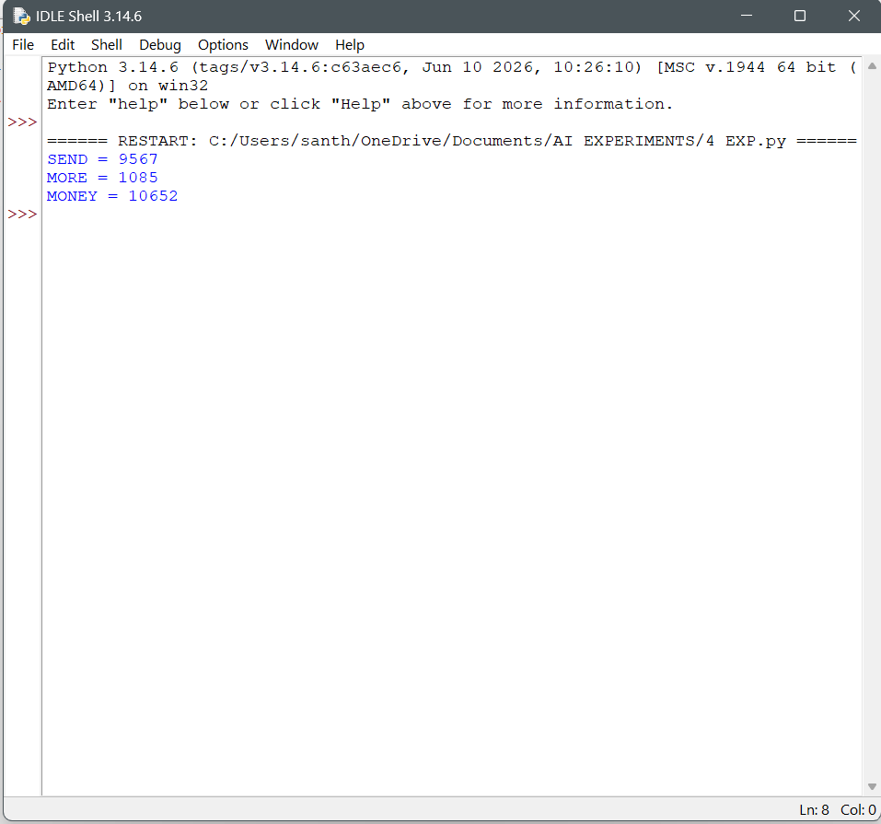

5. Missionaries and Cannibals Problem
Aim: Transport missionaries and cannibals safely across a river.

Program
from collections import deque

# State: (missionaries_left, cannibals_left, boat_side)
start = (3, 3, 0)
goal = (0, 0, 1)
moves = [(1, 0), (2, 0), (0, 1), (0, 2), (1, 1)]

def valid(m, c):
if not (0 <= m <= 3 and 0 <= c <= 3):
return False
mr, cr = 3 - m, 3 - c
return (m == 0 or m >= c) and (mr == 0 or mr >= cr)

queue = deque([(start, [start])])
visited = {start}

while queue:
state, path = queue.popleft()
if state == goal:
for s in path:
print(s)
break

m, c, boat = state
for dm, dc in moves:
if boat == 0:
new = (m - dm, c - dc, 1)
else:
new = (m + dm, c + dc, 0)

if valid(new[0], new[1]) and new not in visited:
visited.add(new)
queue.append((new, path + [new]))

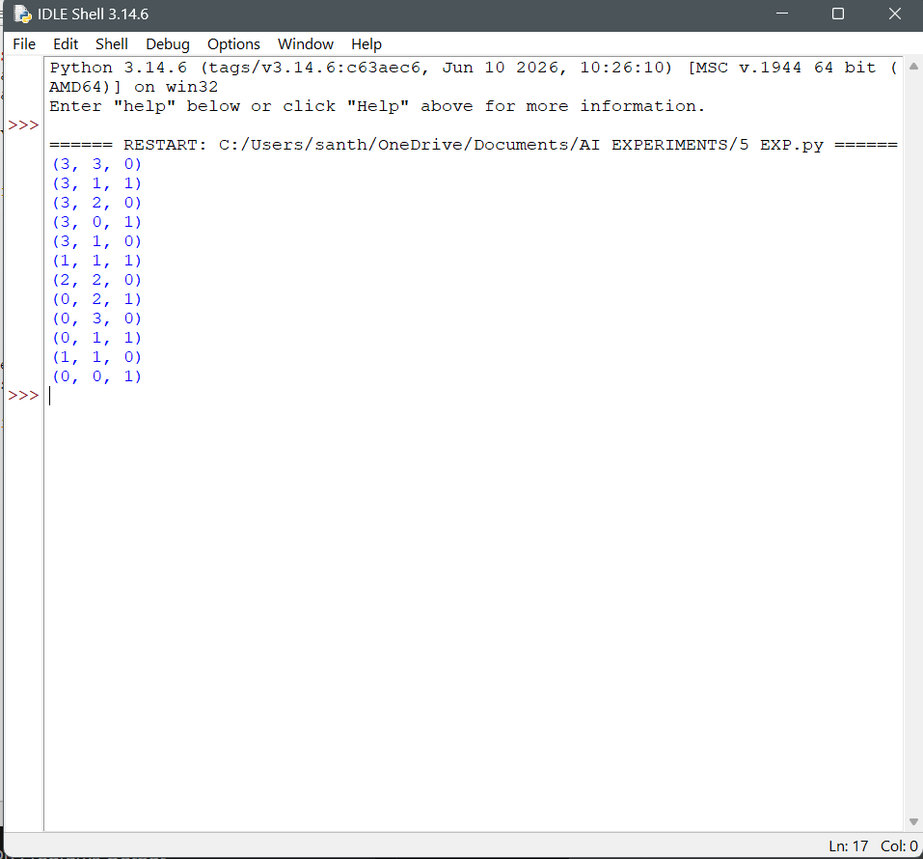
6. Vacuum Cleaner Problem
Aim: Clean two rooms using a simple vacuum-cleaner agent.

Program
rooms = {"A": "Dirty", "B": "Dirty"}
position = "A"

while "Dirty" in rooms.values():
print("Vacuum at", position)

if rooms[position] == "Dirty":
rooms[position] = "Clean"
print(position, "room cleaned")

position = "B" if position == "A" else "A"

print("All rooms are clean")

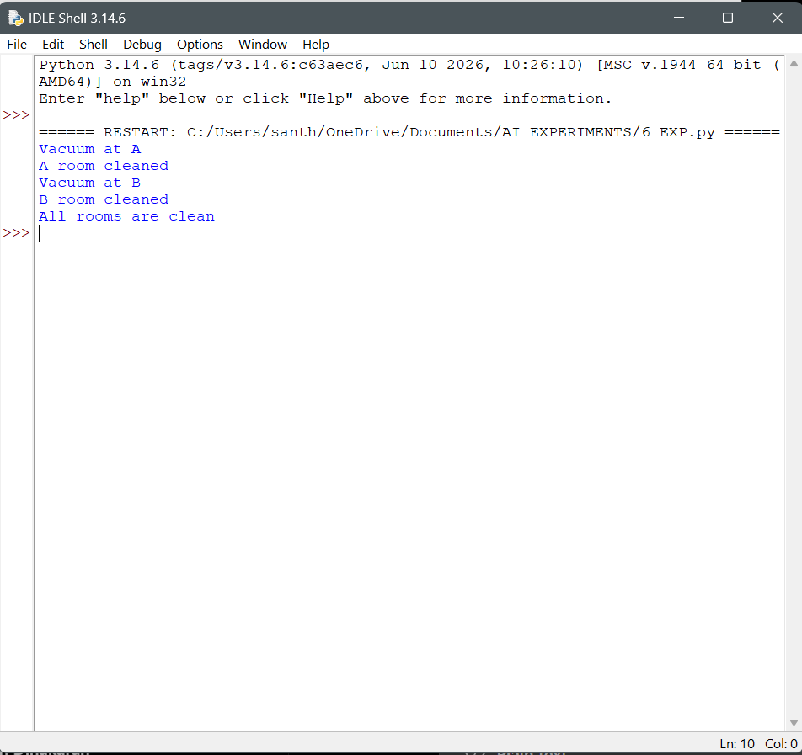

7. Breadth-First Search (BFS)
Aim: Traverse a graph using Breadth-First Search.

Program
from collections import deque

graph = {
"A": ["B", "C"],
"B": ["D", "E"],
"C": ["F"],
"D": [],
"E": [],
"F": []
}

def bfs(start):
visited = {start}
queue = deque([start])

while queue:
node = queue.popleft()
print(node, end=" ")
for neighbor in graph[node]:
if neighbor not in visited:
visited.add(neighbor)
queue.append(neighbor)

bfs("A")
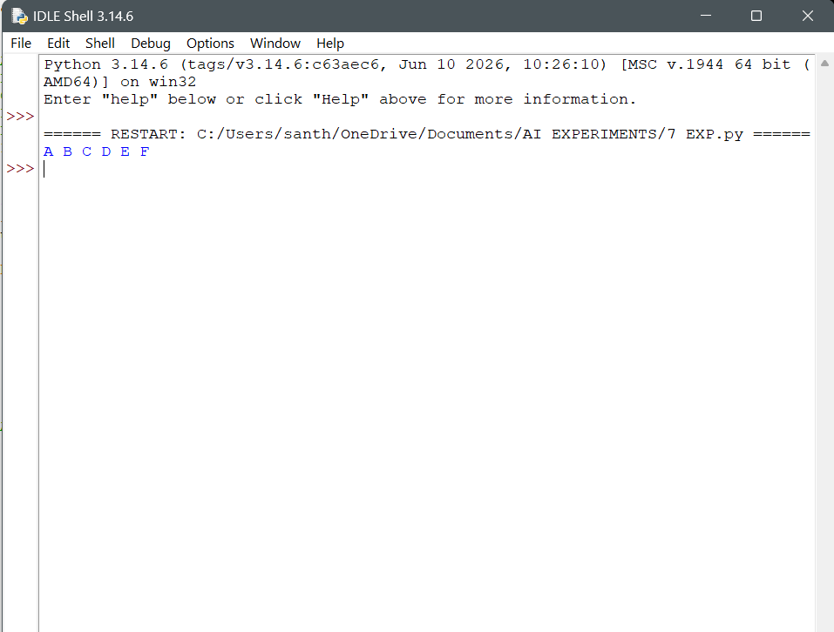

8. Depth-First Search (DFS)
Aim: Traverse a graph using Depth-First Search.

Program
graph = {
"A": ["B", "C"],
"B": ["D", "E"],
"C": ["F"],
"D": [],
"E": [],
"F": []
}

visited = set()

def dfs(node):
if node not in visited:
print(node, end=" ")
visited.add(node)
for neighbor in graph[node]:
dfs(neighbor)

dfs("A")
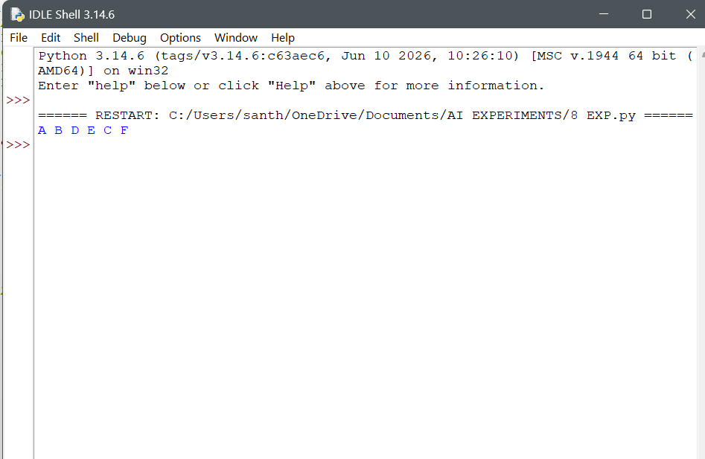

9. Travelling Salesman Problem (TSP)
Aim: Find a minimum-cost tour through all cities.

Program
from itertools import permutations

dist = [
[0, 10, 15, 20],
[10, 0, 35, 25],
[15, 35, 0, 30],
[20, 25, 30, 0]
]

n = len(dist)
start = 0
best_cost = float("inf")
best_path = []

for p in permutations(range(1, n)):
path = (start,) + p + (start,)
cost = sum(dist[path[i]][path[i + 1]] for i in range(n))

if cost < best_cost:
best_cost = cost
best_path = path

print("Best path:", " -> ".join(str(city + 1) for city in best_path))
print("Minimum cost:", best_cost)

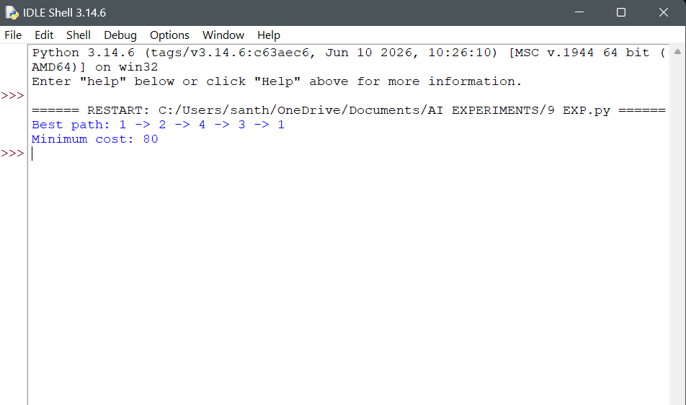

10. A* Algorithm
Aim: Find a path using A* heuristic search.

Program
import heapq

graph = {
"A": [("B", 1), ("C", 3)],
"B": [("D", 3), ("E", 5)],
"C": [("E", 2)],
"D": [("G", 4)],
"E": [("G", 2)],
"G": []
}

h = {"A": 5, "B": 4, "C": 3, "D": 4, "E": 2, "G": 0}

def astar(start, goal):
pq = [(h[start], 0, start, [start])]
best = {start: 0}

while pq:
f, g, node, path = heapq.heappop(pq)

if node == goal:
return path, g

if g > best.get(node, float("inf")):
continue

for neighbor, cost in graph[node]:
new_g = g + cost
if new_g < best.get(neighbor, float("inf")):
best[neighbor] = new_g
heapq.heappush(
pq, (new_g + h[neighbor], new_g,
neighbor, path + [neighbor])
)

return None, float("inf")

path, cost = astar("A", "G")
print("Shortest path:", " -> ".join(path))
print("Total cost:", cost)

